**COMSATS University Islamabad, Abbottabad Campus**

**Department of Computer Science**

**Project Proposal**

**Contextual Chatting App**

**CSC392 Object Oriented Software Engineering**

**Submitted on:** < >

**Group Members:**

**Arqum Ejaz (SP21-BSE-039)**

**Arsal Bilal (SP21-BSE-040)**

**Sarmad Haseeb (SP21-BSE-023)**

**Ihsan-ul-Haq (SP21-BSE-013)**

**Yaseen Sajid (SP21-BSE-027)**

**Muhammad Shoaib (SP21-BSE-035)**

**Ozair Idrees (SP21-BSE-029)**

**Saifullah (SP21-BSE-022)**

Table of Contents

[CHAPTER 1 PROJECT PROPOSAL 3](#_Toc101427096)

[Introduction 3](#_Toc101427097)

[Vision and Business Case 3](#_Toc101427098)

[Use-Case Model 4](#_Toc101427099)

[Supplementary Specification 4](#_Toc101427100)

[Glossary 4](#_Toc101427101)

[Risk List & Risk Management Plan 5](#_Toc101427102)

[CHAPTER 2 USE CASES 5](#_Toc101427103)

[Use Case Diagram 5](#_Toc101427104)

[Brief Level Use Cases 6](#_Toc101427105)

[Student Name 1 (Registration Number 1) **Error! Bookmark not defined.**](#_Toc101427106)

[Student Name 1 (Registration Number 1) **Error! Bookmark not defined.**](#_Toc101427107)

# CHAPTER 1 PROJECT PROPOSAL

## Introduction

# Contextual chatting app is a platform where users can get and share opinion from people of respective field. Sometimes we have some queries regarding any field and we look for people of the respective field to solve our queries. CCA will give us that platform.

# In order to use the app the user first has to get registered with the app. After registration the user will log in to the app. The user will enter dashboard at the login from where he/she can visit profile and select the field of their interest.

After selecting the field user will search group if he/she knows about any group in the app otherwise they will join any group to send or view message in it. User can send text message, picture or video in the group. User will also have the option of rate message like thumbs up. Your will also have the option of exit group by clicking on exit group button.

User have the option of chat backup to cloud storage or local drive. User can manage his profile from manage profile option in the app. He/she can logout from their respective account.

Admin will login through login portal. Only admin can create group and delete group from the app. He/she have the rights to manage user as well.

## Vision

The vision of the CCA is to make an app in which user can select group of own choice and can guide or guided by other user in the same group. All the members in the group will be of respective interest and they can guide their new user about problem being asked in group. This will help people of same interest a lot and make them easy to understand and analyze the problem.

For this user must register with the app and select field and group of interest. He can also leave group if problem is solved. User can satisfy other user by text message or by share image in group or by making video.

This will save the time of users and will fill the communication gap between the users.

EXECUTIVE SUMMARY:

CCA will provide a platform where users can get and share opinion from people of respective field. In order to use the app the user first has to get registered with the app. User can search group if he/she knows about any group in the app otherwise they will join any group to send or view message in it.

High-level goals and constraints:

|  |  |  |  |
| --- | --- | --- | --- |
| High-level Goals | Priority | Problems and Concerns | Current Solutions |
| Fast, user friendly, chatting app | High | Website link down in case of high use. |  |

Business Case:

User chat management: user data of chatting will be managed in contextual chatting app database.

App management: all the app data will be managed and stored in database.

Reward management: In this module it will manage the reward system of contextual chatting app management.

## Use-Case Model

* **Register user**: it will perform the local login function
* **Login**: it will perform the local login function
* **Search group:** user will search group by entering name of group.
* **Join group:** user will join group by clicking join group button
* **Manage user profile:** this includes user name password and profile setting.
* **Send message:** user can send message after joining group.
* **View message:** user can view messages of joined groups.
* **Rate message:** user can rate message of other user in group.
* **Create backup for chats:** this include backup to Google drive or local storage.
* **Create group:** only admin can create group in app.
* **Delete group:** only admin can delete group user can only exit group.

## Supplementary Specification

* **Availability:** app data available to user at any time he used app.
* **Reliability:** the app should de reliable and easy to user.
* **Safety:** user data of app must be safe.
* **Security:** login authentication of user must be secure.
* **Efficiency:** app must be efficient.
* **Modifiability:** app will be able to adopt changes in it.

## Glossary

**CCA:** contextual chatting app

## Risk List & Risk Management Plan

|  |  |
| --- | --- |
| **Risk** | **Risk Management Plan** |
| **Programming languages risks** | Members will try to learn from fellow group members who know languages like java, web technologies. |
| **Database management risks** | Members will try to learn from fellow group members who know database. |
| **Remote group member risks** | All the group members are not at the same place every time so we made a group to discuss about project. |

# CHAPTER 2 USE CASES

## Use Case Diagram

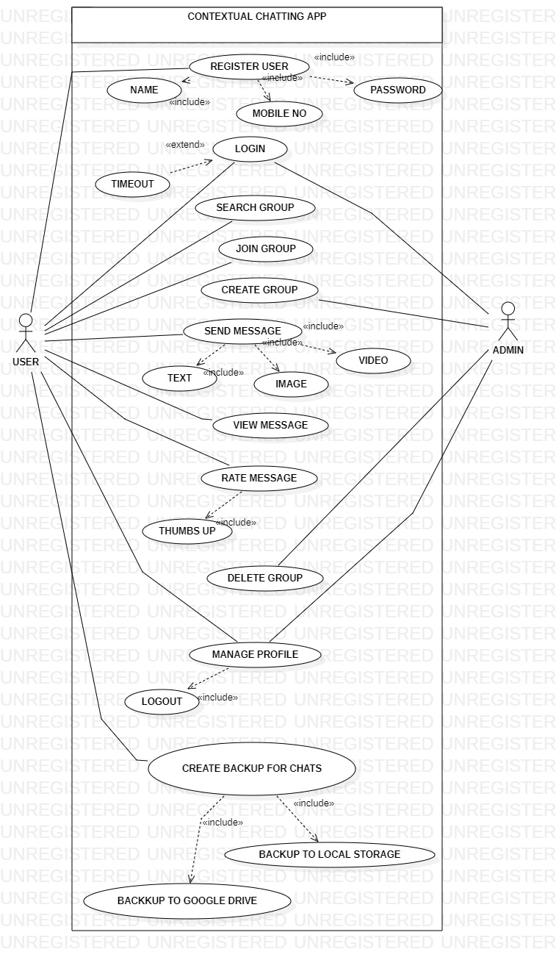

## 

## Brief Level Use Cases

### Arqum Ejaz (SP21-BSE-039)

#### Use Case: register user

In this use case user will get registered will the Contextual chatting app if he/she is currently not a registered user. The user will be asked to choose a valid username and password in order to get registered. The user must be a registered user if he wants to use the app.

### Arsal Bilal (SP21-BSE-040)

#### Use Case: login

In this use case user will login through id and password and entered the Contextual chatting app if he/she is currently not a registered user than first register and then proceed to the login process. When user entered the login id and their password, he/she will use the features of app.

### Yaseen Sajid (SP21-BSE-027)

#### Use Case: manage profile

In this use case the user which is register on app can manage his profile like profile picture, personal email. User can also add the name user can also add the list of his daily life activities. On the basis of his interest he can also join the groups

### Ozair Idrees (SP21-BSE-029)

#### Use Case: create group

In this use case user will get registered as "Admin" on the Contextual Chatting App. After that he/she can create a group with a specific name and allow the registered users to join the group to discuss the related problems/issues and suggest their solutions.

### Ihsan ul Haq (SP21-BSE-013)

#### Use Case: join group

In this use case the user joined the group that already created by application admin. After that user send, receive the messages and contribute in the group.

### Saifullah (SP21-BSE-022)

#### Use Case: send message

In this use case the user can send message to group that he/she joined. For this user select group of its choice and type message in the specified field and then click on send icon. To send message successfully, user must have valid internet connection. The sender message may be text message, picture or video. User will be able to send message at any time.

#### Use Case: view message

In this use case the user can view messages in group that he/she joined. For this user must select a specific group at a time to view all the messages in it and there is no need of internet connection to view messages. The view message may be text message, picture or video. User can see any message at any time.

#### Sarmad Haseeb (SP21-BSE-023)

#### Use Case: rate message

In this use case user will go to the app through proper channel (like he/she must be registered and login to the app) and then open the chat. When the user viewed the messages after this, he will be able to rate the related message. The user must be registered user if he wants to use the app.

### Muhammad Shoaib (SP21-BSE-035)

#### Use Case: create backup for chats

In this use case, The User will be able to backup his/her chat depends on user setting. They will be able to back-up their chat to Google drive or email account. The chat of a user will save to the Google drive or email account. The main purpose of chat backup is to avoid the loss of user data (messages, pictures and videos).The User also have an option of “never” back up chat if he/her wants.

Fully Dressed Use Cases

### Arqum Ejaz (SP21-BSE-039)

#### Use Case: register user

|  |  |
| --- | --- |
| Use case name | Register user |
| Scope | Contextual chatting app |
| Level | User goal |
| Primary actor | User |
| Stakeholder and interest | * Admin: Admin will have the notice of newly registered users. The admin will have record of all the registered users. * Users: Users will have a new user to discuss queries and problems regarding any respective matter. |
| Precondition | The user must have stable internet connection. |
| Success guarantee (post condition) | After registering can log in to the App. |
| Main success scenario | 1. The admin will have notice when a new user registers with the app 2. The groups will get another individual to discuss matters of certain concern. 3. The user if satisfied by the app will promote the app and more users will enter the app. |
| Exception | * User could not register due to server issues. * User could not get register if he have some connection issue |
| Special requirement | At the time of registration, The user must enter password of more than 7 characters and less than 30. |
| Technology and data variation list |  |
| Frequency of occurrence |  |
| Miscellaneous |  |

**Screen Shots:**

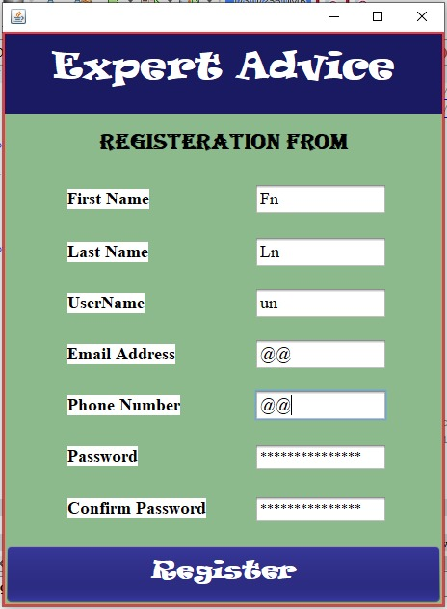

### Arsal Bilal (SP21-BSE-040)

#### Use Case: login

|  |  |
| --- | --- |
| Use case name | Login |
| Scope | Contextual chatting app |
| Level | User goal |
| Primary actor | User |
| Stakeholder and interest | * Admin: When user entered their email and password admin check if his/her information is in the server than it will proceed to the main menu of the app. * Users: User after login chat with contacts and the groups of their interest |
| Precondition | The user must have stable internet connection. |
| Success guarantee (post condition) | After login user can chat into the App and see the news feed of their interest and read the information about their field of interest. |
| Main success scenario | 1. The admin will have notice when a new user login with the app 2. The groups will get another individual to discuss matters of certain concern. 3. The user if satisfied by the app will promote the app and more users will enter the app. |
| Exception | * User could not login due to server issues. * User could not get login if he has some connection issue |
| Special requirement | At the time of login, the user must have stable internet and the username and password will be same as the time of registration else user will not succeed to the app menu. |
| Technology and data variation list | The app is only available in operating system, so user have the operating system. Operating system version is greater than version 7, than this app will work properly. |
| Frequency of occurrence |  |
| Miscellaneous |  |

**Screen Shots:**

### **C:\Users\CUI\Downloads\image_2022-11-09_052501196.png**

### Yaseen Sajid (SP21-BSE-027)

#### Use Case: manage profile

|  |  |
| --- | --- |
| Use case name | Manage profile |
| Scope | advanced features |
| Level | User goal |
| Primary actor | User |
| Stakeholder and interest | User: update his profile so that communication barrier can be as less as possible |
| Precondition | User must be register on the app |
| Success guarantee (post condition) | After updating the profile the user can get more thing about related field it beneficial for the user and admin also. |
| Main success scenario | First the application administration know the demanded and easy design of the application that which thing is in demand in the market. |
| Exception | Manage profile will not work if there is bad internet connection |
| Special requirement | User must be registered on the app |
| Technology and data variation list |  |
| Frequency of occurrence |  |
| Miscellaneous |  |

**Screen Shots:**

**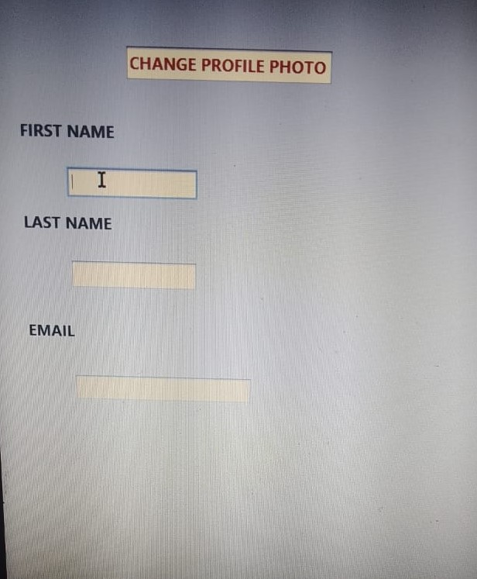**

### Ozair Idrees (SP21-BSE-029)

#### Use Case: create group

|  |  |
| --- | --- |
| Use case name | Create Group |
| Scope | Contextual chatting app |
| Level | User goal |
| Primary actor | Admin |
| Stakeholder and interest | * **Admin:** Admin will create the group and only registered users can be added in the group. |
| Precondition | Admin will also the registered user. |
| Success guarantee (post condition) | After registration users can join the groups. |
| Main success scenario | * The admin will get the request from user and accept/delete the request of user after reviewing the information of user. * The user if satisfied by the group will promote the group and more users will enter the app. |
| Exception | * User can create group if did not register as "Admin". |
| Special requirement | * One users can join maximum 10 groups at a time. * Maximum 3 users can be the "Admin" of group. |
| Technology and data variation list | Internet connection |
| Frequency of occurrence |  |
| Miscellaneous |  |

**Screen Shots:**

**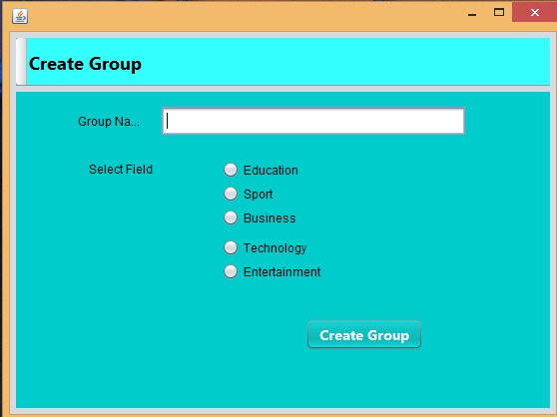**

### Ihsan ul Haq (SP21-BSE-013)

#### Use Case: join group

|  |  |
| --- | --- |
| Use case name | Join Group |
| Scope | advanced features |
| Level | User goal |
| Primary actor | User |
| Stakeholder and interest | Admin: wants to create more groups if more user interested in any field.  User: wants to join the field of group on the basis of any user positive review. |
| Precondition | Every member join the group as a user not an admin. |
| Success guarantee (post condition) | After joining the group user can get more thing about related field it beneficial for the user and admin also. |
| Main success scenario | First the application administration know the demanded and easy design of the application that which thing is in demand in the market. |
| Exception | The. |
| Special requirement | If any user join the group he/she see all the related things and material in the group and on the application. |
| Technology and data variation list |  |
| Frequency of occurrence |  |
| Miscellaneous |  |

**Screen Shots:**

**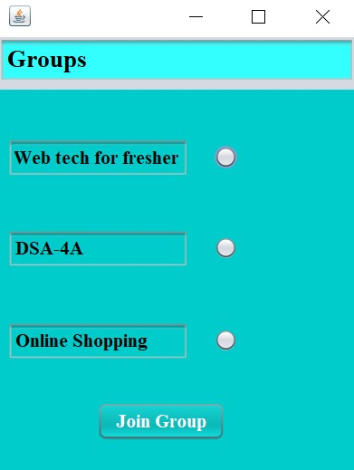**

### Saifullah (SP21-BSE-022)

#### Use Case: send message

|  |  |
| --- | --- |
| Use case name | Send message |
| Scope | Contextual chatting app |
| Level | User goal |
| Primary actor | User |
| Stakeholder and interest | * Users: Users will have a new user to discuss queries and problems regarding any respective matter. |
| Precondition | * The user must be already registered user to send message. * The user must have stable internet connection to send message. |
| Success guarantee (post condition) | Message must be delivered and shown to another user if he/she has stable internet connection. |
| Main success scenario | 1. User select group of its choice to send message in it. 2. User type the message in the specified type area and click on send icon. 3. Message may include text message, image or video. 4. Message will be send to other group members if user have valid internet connection. |
| Exception | * User must have account to send message to another user. * User cannot be able to send message if he has some connection issues. |
| Special requirement | User must joined group to send message in group. Also valid connection to send message successfully. |
| Technology and data variation list | Internet connection. |
| Frequency of occurrence | Infinity |
| Miscellaneous |  |

**Screen Shots:**

**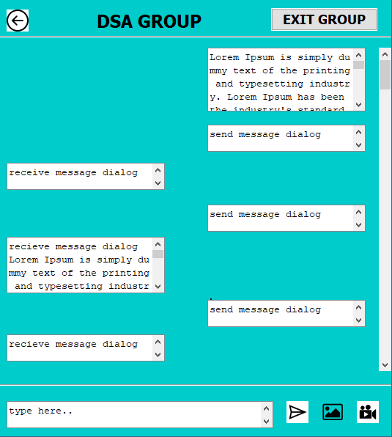**

#### Use Case: view message

|  |  |
| --- | --- |
| Use case name | View message |
| Scope | Contextual chatting app |
| Level | User goal |
| Primary actor | User |
| Stakeholder and interest | * Users: Users will have a new user to discuss queries and problems regarding any respective matter. |
| Precondition | * The user must be already registered user to receive message. * There is no need of stable internet connection to view messages |
| Success guarantee (post condition) | Message must be shown to another user either he has internet connection or not. |
| Main success scenario | 1. The user can select group of its own choice to view messages in it. 2. User can see all the previous messages if he has not valid connection currently. 3. Message may include text message, image or video. |
| Exception | * User must have account to view message from another users. * User can be able to view message if he has some connection issues. |
| Special requirement | User must joined group to view message in group. |
| Technology and data variation list | Internet connection. |
| Frequency of occurrence | Infinite |
| Miscellaneous |  |

**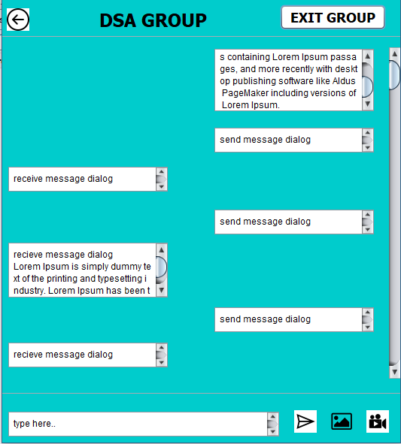Screen Shots:**

#### Sarmad Haseeb (SP21-BSE-023)

#### Use Case: rate message

|  |  |
| --- | --- |
| Use case name | Rate Message |
| Scope | Contextual chatting app |
| Level | User goal |
| Primary actor | User |
| Stakeholder and interest | * Users: Users will know which of the comments contains best information as the most rated comment will be displayed at the top. |
| Precondition | User must have received and then seen the messages to rate up. |
| Success guarantee (post condition) | After rating user can see a thumbs up sign with the message. |
| Main success scenario | 1. Users can see the rated messages. 2. Most rated messages will be at the top of group. |
| Exception | * User could not give rating due to connection error or server error. |
| Special requirement | The user can only rate once on a message i.e., user cannot give more than one thumbs up on a single message. |
| Technology and data variation list | Internet connection |
| Frequency of occurrence |  |
| Miscellaneous |  |

**Screen Shots:**

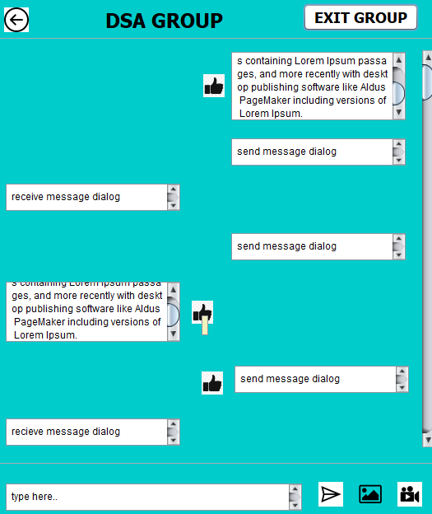

### Muhammad Shoaib (SP21-BSE-035)

#### Use Case: create backup for chats

|  |  |
| --- | --- |
| Use case name | Create Chat Backup |
| Scope | Contextual chatting App |
| Level | User goal |
| Primary actor | User |
| Stakeholder and interest | * User: want to backup his/her chat to the local memory of the device. * User: can also backup chat (messages, pictures and videos) to the Google Drive or email account depend on user setting. |
| Precondition | * The user must be register and login to the system * The user must visit the setting to backup chat according to his/her need. * The user must have a stable internet connection. * User must have memory on local device or google drive for the backup data. |
| Success guarantee (post condition) | After visiting setting of backup chat, User can now backup chat according to his/her need. |
| Main success scenario | 1. The user will visit the setting.  2. The user will click on the backup chat.  3. The user can backup chat to local memory or google drive. |
| Exception | * If the user is not able to backup chat, then he/she should refresh the page or check the internet connection. * The user should be re-visiting the setting after checking the internet. |
| Special requirement | If Back Up option does not work, the system will immediately show the message could not back up to the user. |
| Technology and data variation list | * The programming language used is java. * The interface is designed using Net Beans. |
| Frequency of occurrence | This will occur multiple times as the user wants to view according to his/her setting. |
| Miscellaneous | Can the User back up his/her deleted messages to his/her device? |

**Screen Shots:**

